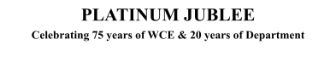

# Walchand College of Engineering, Sangli

***(Government Aided Autonomous Institute)***

Department of Information Technology

Computer Networks Lab

EVEN SEMESTER AY 2021-22

*Submitted by*

Name: Om Gharge

PRN: 2020BTEIT00041

Batch: S2

Course Code: 5IT272 Date: 25/05/2022

Contact Number: 9730369761

**Department of Information Technology**

2021-22

**Experiment Number:** 7

**Experiment Name:** Implement Routing Information Protocol (RIP) to observe the on-demand up gradation of routing table to configure multiple gateways on the Internet.

# Contents:

**Problem Statement:** Implement Routing Information Protocol (RIP) to observe the on-demand up gradation of

routing table to configure multiple gateways on the Internet.

**Platform:** CISCO packet tracer

**Devices Required:** PC, Switch (2960-24TT) and Router (2621XM)

**Design:**

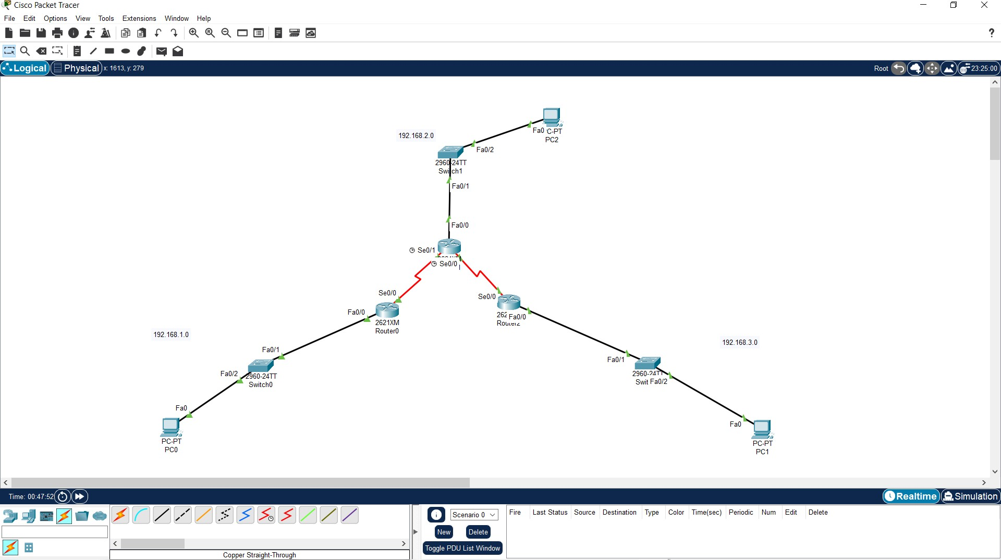

**Implementation:**

1. Create the topology.
2. After creating the topology add WIC - 1 port to the router.
3. Configure the network.
4. write command “route rip”, this command places the switch in router-rip configuration mode to configure the routing information protocol routing process.
5. next command is “network ip”, here we have to put ip on the networks with which the router is connected.

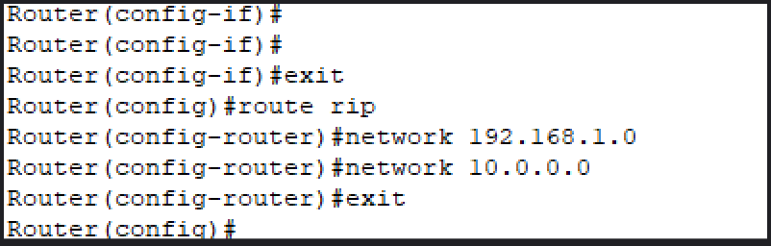

1. Repeat this same for all the routers.

vi) Now enter “do show ip route” which will tell you the route table.

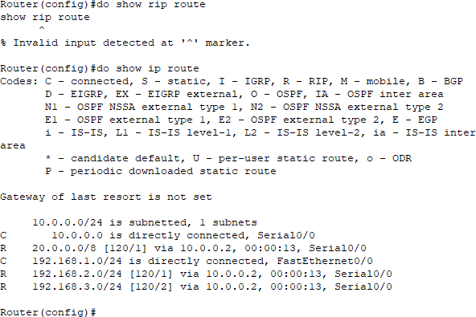

**Results:** All the routers update their route table using routing interface protocol.

